**Project Design**

Original UML

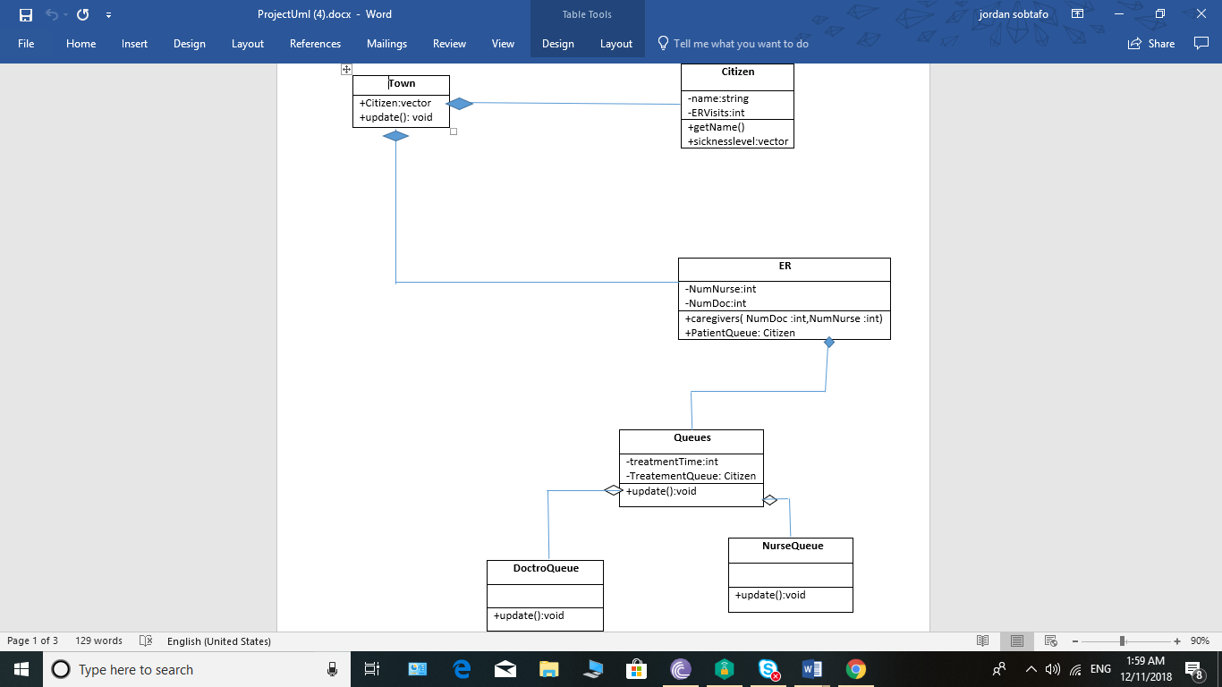

Final UML

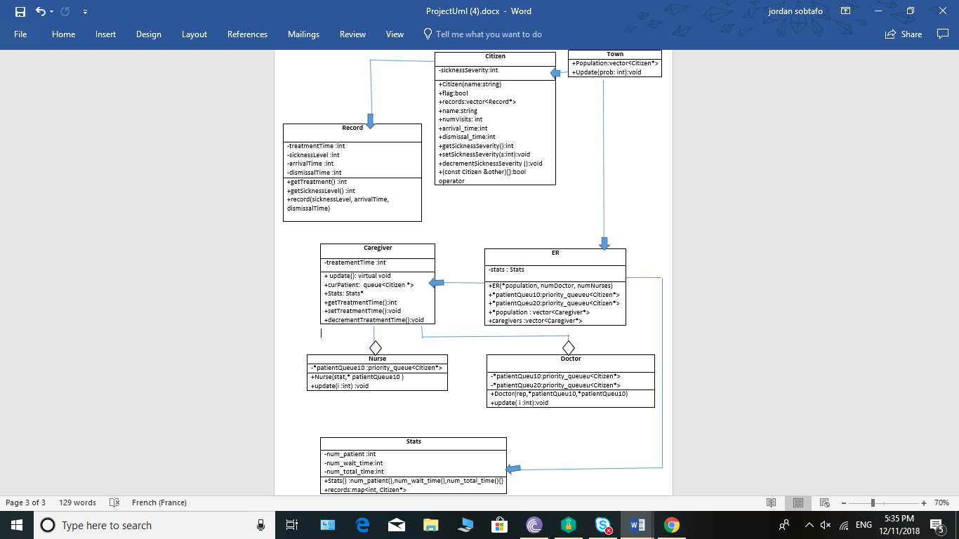

Requirement specification:

The premise of this simulator is to see how well a hospital (ER in our case) will run depending on how many doctors and nurses we have currently working which the user will enter at the beginning. After the simulator runs completely, the average time of visit will be displayed on the console which accounts for a week in the ER. A menu will then prompt the user which allows the user to list all the names of all the residents that were treated, or to retrieve a resident’s record by name. If the user chooses to see all the residents who were treated, they will see the residents’ index value and their name. They will then have the option to enter the residents’ index value to review the patient's’ record. The record for the patient will display their sickness severity level and their average time of treatment.

For our simulator, we will have a total of 8 classes. The 8 classes are caregiver, citizen, doctor, ER, nurse, record, stats, and town. The pure virtual, or base class, is the town. The town class has a citizen class which has a record. In addition, the town class has an ER which has statistics for the patients. The ER also has caregivers. The two types of caregivers are nurses and doctors.

We do not have pseudo-code because the files were killed in Github.

* Use cases:
  + Subproblems:
    - Enter variables to start the program
    - Enter names to view specific results

Use case for starting the program

|  |  |  |
| --- | --- | --- |
| **Step** | **User’s Action** | **System’s Response** |
| 1. | User enters the number of nurses |  |
| 2. |  | System creates this many Nurse objects within ER then prompts user for number of doctors |
| 3. | User enters the number of doctors |  |
| 4. |  | System creates this many Doctor objects within ER then prompts user for average number of patients per hour |
| 5. | User enters average number of patients per hour |  |
| 6. |  | System uses this to calculate the probability that someone will get sick and then runs the simulation and outputs the statistics |

Use case for viewing results

|  |  |  |
| --- | --- | --- |
| **Step** | **User’s Action** | **System’s Response** |
| 1. | User enters yes to viewing patient records |  |
| 2. |  | System displays names of treated patients and then prompts the user to enter the name of a patient to see their record |
| 3. | User enters the index value of someone to view |  |
| 4. |  | System displays their record and then prompts the user to exit or enter another |
| 5. | User enters exit |  |
| 6. |  | System repeats |
| 7. | Else |  |
| 8. |  | Exit program |